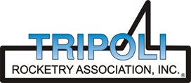
Tripoli Motor Testing Division
223 NC Highway 54 West
Chapel Hill, NC 27514
(919) 357 5681 (c)
May 12, 2018

Gary Rosenfield
RCS Rocket Motor Components, Inc.
2113 West 850 North Street
Cedar City, UT 84721

Dear Mr. Rosenfield,

The Quest Q-Jet C12-4,6,8FJ single-use motor was tested on May 2, 2018 and is in compliance with NFPA 1125. The motor is certified for hobby rocketry use by the members of the Tripoli Rocketry Association and all approving organizations with reciprocal certifying agreements.

Motor Manufacturer Quest Division, RCS Rocket Motor Components
Manufacturer’s Designation C12-4,6,8FJ [18mm single use]
Propellant Black Max
TMT Nomenclature 9.8 C11.6

Diameter - 18 mm
Overall Length 3.10” 78.7 mm
Case Length 2.701” 68.61 mm

Loaded Mass .0523 lb 23.7 g
Propellant Mass .0229 lb* 10.4 g*
Burnout Mass .0292 lb 13.2 g

Burn time 0.843 ± .029 sec

Total Impulse 2.203 ± .048 lbf.s 9.80 ± .21 N.s
Max Impulse 3.944 ± .260 lbf 17.54 ± 1.16 N
Average Impulse 2.615 ± .131 lbf 11.63 ± .58 N
Number of Motors Tested 11
Nominal Measured
Delay Time Data 4 s 4.939, 5.28, 4.787, 4.541 sec
6 s 5.167, 4.706, 6.829, 6.08 sec
8 s 9.15, 9.086, 7.743 sec

Casing Temp. [NFPA 1125 7.4.1] Passed

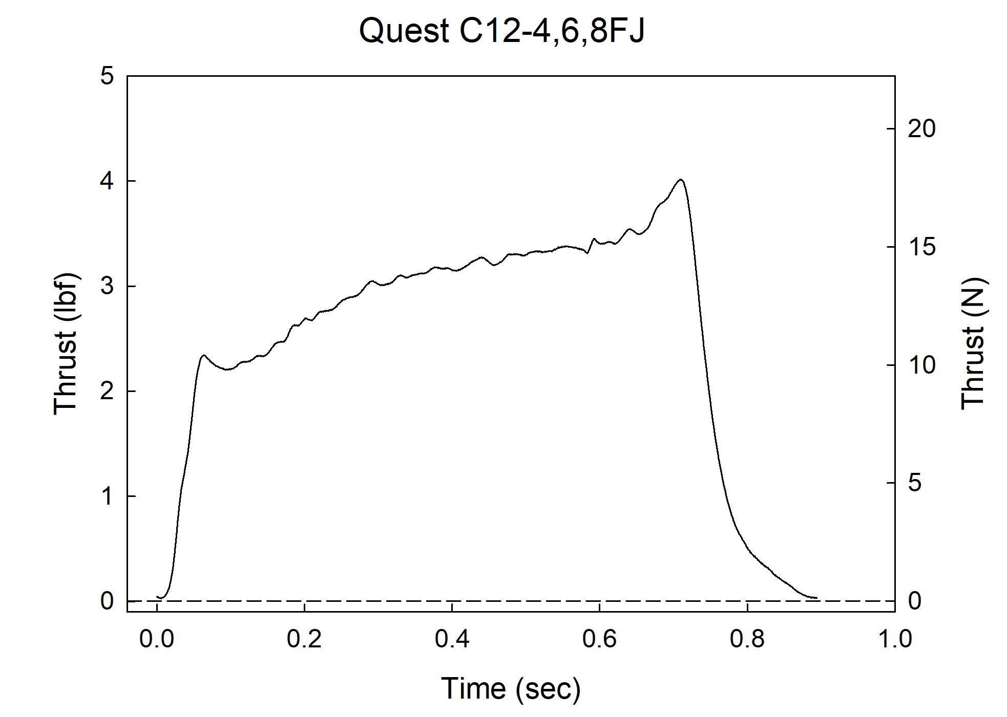

Sincerely,

Alan C. Whitmore
Chair, Tripoli Motor Testing

